**Project 3 Phase 2 Report**

Ke Ma 112846615

Honglei Liu 112848525

1. **Module description**

There are two modules in the design, which is Mobile and Server.

In the Mobile module, there are methods for processing data and generate packets, there is a method used to send these packet to Server module, there is another method used to receive image from server. Mobile listen to Server and only send packet to Server when the network is free.

In the Server module, there are two methods. One is for receiving packet from Mobile, one is for sending image to Mobile. At the same time Server control the network. When it is sending image to Mobile it sets the network to busy, which means the Mobile can not send packet to Server and has to wait.

1. **Description for handshake mechanism**

When there are 20 packets and the network is free, then the Mobile is able to send packet to Server and at the same time, the network is set to busy at the Server side. When the Mobile has sent all the data, the network is set to free again.

At Server side, Server has to send the image packet to Mobile. When the Server is sending data, the network has be set to busy, which means that Mobile can not send at this time. Mobile keeps listening to the network until the network is free.

1. **Simulation result**

In the simulation, I will take Image_pack_size equals to 1Kb,

bandwidth equals to 1Mbps, delta equals to 100ms for example.

Server send image packet at the very beginning of simulation. In this image, the server begins to send the first image packet of Image_1 at 10ms, at 30 ms Mobile1_1 receives this packet and then Server set network to free:

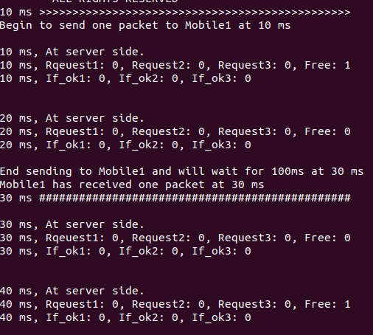

Since Delta time equals to 100ms, so at 130ms, Server sends the first image packet of Image_2:

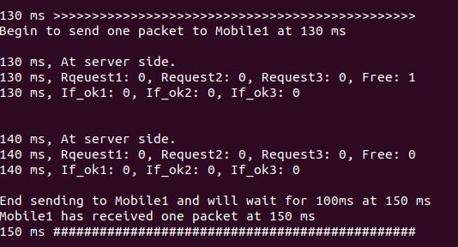At 510ms, Mobile_1 has received first image of Image_5 and at 610ms, Mobile_2 received the first packet of the Image_1:

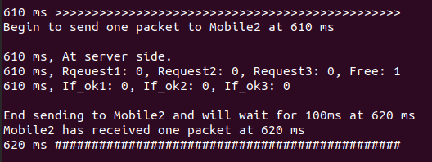Mobile_3 receives the image packet is similar to Mobile_1 and Mobile_2.

At 1610ms, Mobile_1, Mobile_2, Mobile_3 has received all the packet of 5 images:

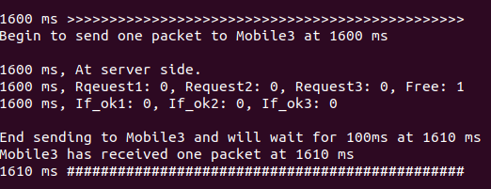

At the Mobile side, 3 mobiles began processing image at 200ms. At 225010ms, they finished processing and all of them sent request signal to server, but only Mobile_1 was permitted to send, and Mobile_2 and Mobile_3 were denied, as shown below:

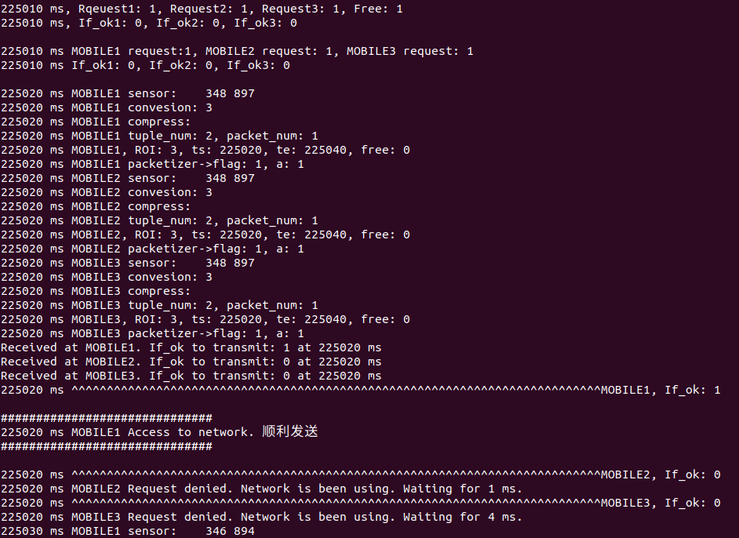

When Mobile_1 finished sending, Mobile_2 was permitted and final Mobile_3 was able to send packet when Mobile_2 was finished, as shown below:

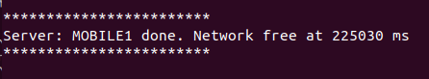

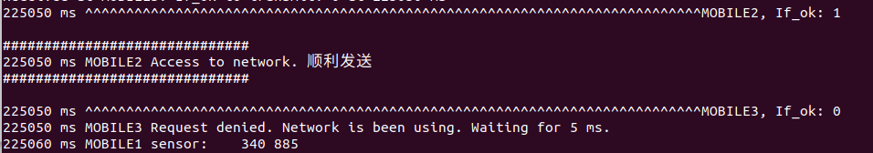



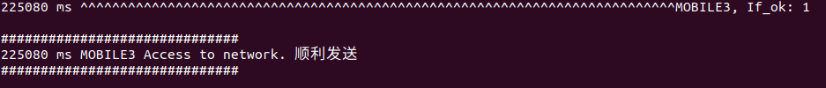

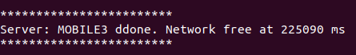

4. Memory plot (Mb vs ms)

